Development Phase 1

Introduction to development phase 1:

In this development phase 1 we are going to cover the programming raspberry pi using python, connecting ultrasonic sensor with raspberry pi which detects the availability of parking spaces and connection diagrams

Introduction to Raspberry pi:

Raspberry pi is a small single board computer. By connecting peripherals like keyboard, mouse, display to the raspberry pi, it will act as a mini personal computer.

Raspberry pi is used for real-time Image or video processing, IoT applications and Robotics.

Raspberry pi is not much faster as laptop/desktop but it can provide all the features at low power consumption.

Raspbian OS:

Raspberry pi foundation officially provides Debian based Raspbian OS and also NOOBS OS for raspberry pi. We can install third party version of OS like Ubuntu, Windows 10 IOT Core etc…

This OS is free to use and efficiently optimized for Raspberry pi. Raspbian have GUI tools for browsing, Python programming and so on.

We should use a minimum 8GB SD Card to store this OS.

Raspberry pi is more than computer as it provides access to on-chip hardware.

For example, GPIOs for developing applications. By accessing GPIO, We can connect devices like LED, motors , Sensors and can control them too

Raspberry Pi processor:

It has ARM based Broadcam processor SoC along with on-chip GPU

The CPU Speed of Raspberry pi varies varies from 700 MHz to 1.2 GHz. It has a on-board SDRAM ranges from 256MB to 1 GB.

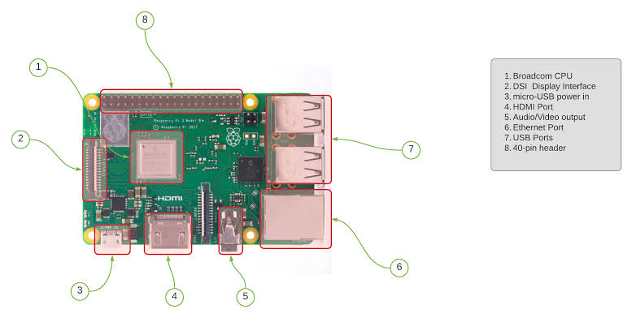

Raspberry Pi

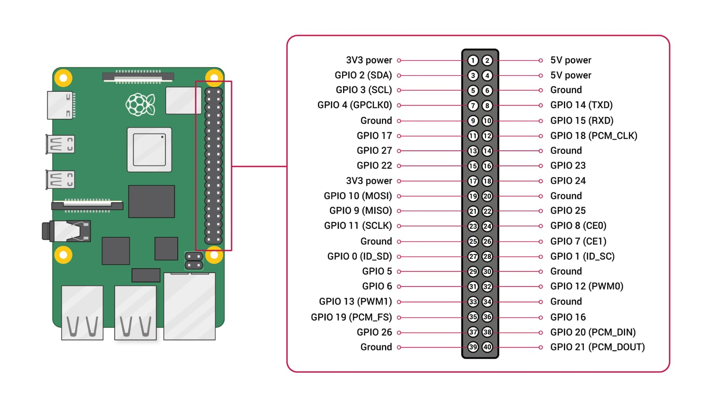

Raspberry Pi GPIO 40 Pin Diagram

Introduction to Ultrasonic Sensors:

Ultrasonic sensors are electronic devices which act as transceivers which is they transmit and receive signals. The Ultrasonic sensors are used to detect the distance of the object by sending Ultrasonic waves and calculate the distance by means of the reflected wave. Which is like how bats use Ultrasonic waves to detect objects and avoid collision. It has four pins. A transmitter and a receiver which acts as a transceiver.

The Four pins are:

1.TRIG – Which Emits Ultrasonic Waves

2.ECHO – Which receives the reflected Ultrasonic Wave

3.VCC – Input Voltage

4.GND – Ground Pin

Ultrasonic Sensors:

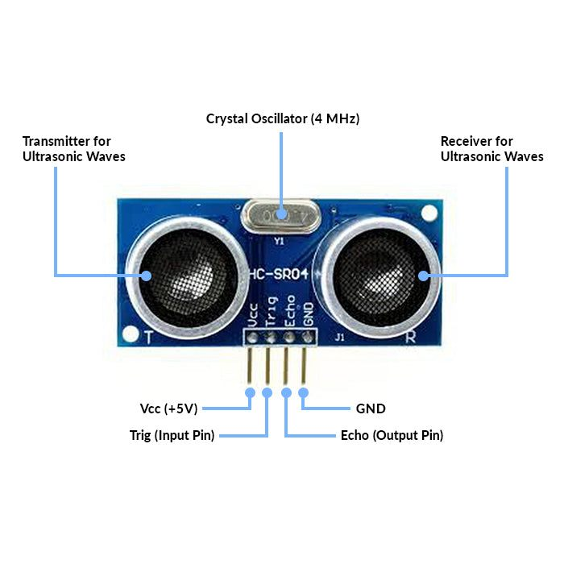Connecting Ultrasonic Sensor with Raspberry Pi:

The Pins of Ultrasonic sensor is going to be connected with the GPIO Pins of Raspberry pi to collect data from the Ultrasonic sensors and to send this to the raspberry pi. The connection circuit as shown below

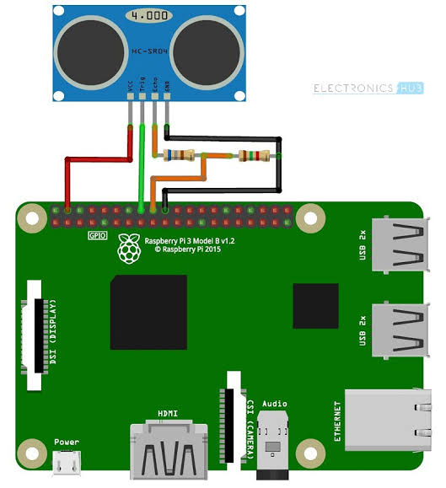

The VCC of sensor is connected with power pin(Pin 2) of Rpi, GND is connected with Ground pin(Pin 20), Echo is connected with GPIO 24(Pin 18) and Trig is connected with GPIO 23(Pin 16).

The Raspberry pi should be provided with micro USB power supply and Ethernet connection.

**Python Code to collect data from Ultrasonic sensors:**

**This program should be loaded on Raspberry Pi**

**Code:**

# Used to connect with raspberry pi and ultrasonic sensor  
import Rpi.GPIO as GPIO  
# For random delay  
import time  
# Used to get the board pins number  
GPIO.setmode(GPIO.BCM)  
# Output pin initialization  
GPIO_TRIG = **11**# Input pin initialization  
GPIO_ECHO = **18**# Setting Trigger as output pin  
GPIO.setup(GPIO_TRIG**,** GPIO.OUT)  
# Setting Echo as input pin  
GPIO.setup(GPIO_ECHO**,** GPIO.IN)  
# Distance calc  
GPIO.output(GPIO_TRIG**,** GPIO.LOW)  
time.sleep(**2**)  
  
GPIO.output(GPIO_TRIG**,** GPIO.HIGH)  
time.sleep(**0.00001**)  
  
GPIO.output(GPIO_TRIG**,** GPIO.LOW)  
# Condition code  
while GPIO.input(GPIO_ECHO) == **0**:  
 start_time = time.time()  
while GPIO.input(GPIO_ECHO) == **1**:  
 Bounce_back_time = time.time()  
pulse_duration = Bounce_back_time - start_time  
distance = round(pulse_duration * **17150, 2**)  
# Printing the output  
print(f"Distance: {distance} cm")  
# cleaning prev o/p  
GPIO.cleanup()